Dear language assistant,
This lesson will be in the lab and it includes three activities: 1) talk about rules in the lab, 2)explanation about the two types of microscope, 3) observation of some specimens using them.
SAFETY IN THE LABORATORY Comments of the picture and reading of the rules.
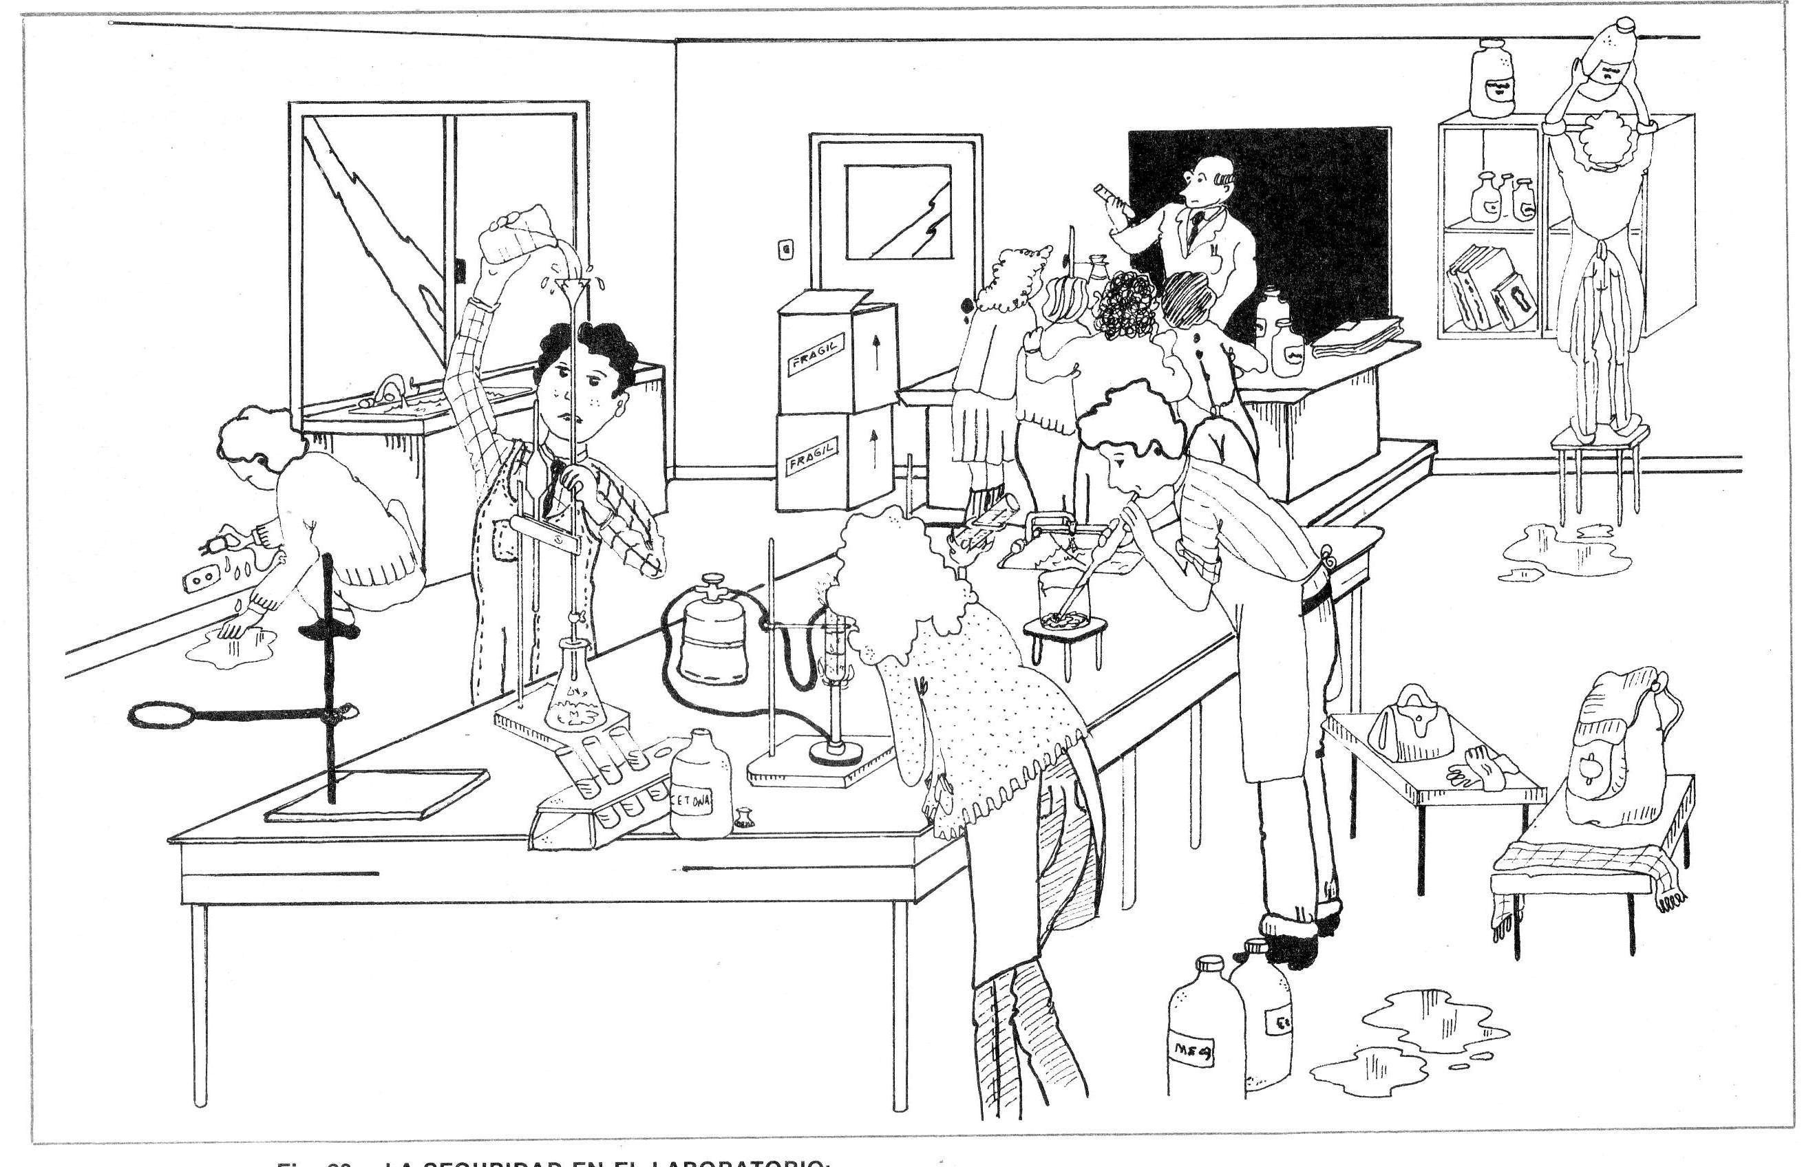

- Stay in your place. Never run or play in the laboratory.
- Don’t remove anything from the laboratory without your teacher's permission.
- Always follow strictly the instructions, especially when you use chemicals, fire, glass instruments or microscopes.
- Put on the laboratory table just the material for the experience and your notebook.
- Draw and write carefully the results.
- When you finish your experience, the material must be clean and tidy.
EXPLANATION ABOUT THE STEREO MICROSCOPE

Parts of the stereomicroscope:
- Eyepiece lens
- Adjustment knob (focuss)
- Stage
- Light source
- Base

Stereomicroscope and compound microscope: What differences can you see?

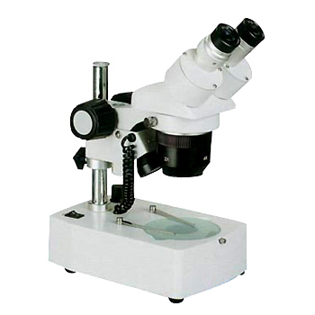  - Always two eyepiece.  - No objectives.  - Stage on the base.  - Light doesn’t pass through the sample.  - Observe in 3D.  - Larger objects.  - Low magnification, 7-30 x | 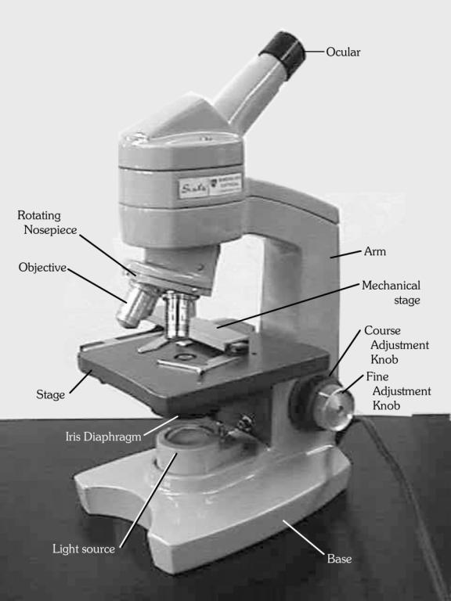  - One or two eyepiece.  - 3-4 objectives.  - Stage in the middle.  - Light pass through the sample.  - Images in 2D.  - Very thin slides.  - Magnification, 30-500x

Today you are observing:
- Little bugs from “cornicabra”.
- Ferns . Look at the clusters of spores behind the leaves.
- Mosses. Look a the very little leaves and at the capsules with the spores.
- Liverworts. The most simple land vegetals. They are in between algae and mosses.

Draw and label everything you observe.
Make drawings clear and large.

