Dear language assistant,

We are going to review how to describe planets:

- Tell me adjectives to express SIZE (big, large, small, medium-size...).Example: Jupiter is very large.
- Tell me adjectives about DISTANCE (far, near, close, second, third, between...). Example: Jupiter is the fifth planet in the Solar System. It is between Mars and Saturn.
- Tell me adjectives about APPEARANCE (red, blue, rings, craters, bands...). Example: Jupiter has coloured bands and many moons. It is similar to Saturn and it’s very different from the Earth.
- You can also use COMPARATIVES AND SUPERLATIVES. Choose the right word.
Mars is bigger/biggest than Mercury.
Venus is the hotter/hottest planet in the Solar System.
Jupiter is the larger/largest planet.
Jupiter is smaller/smallest than the Sun.
Pluto is farther/farthest than Jupiter.
Venus is closer/closest to the Earth than Saturn.

Dictation.

This Solar System has got a sun and four planets. The smallest planet is the third planet and the biggest planet is the fourth planet. The first planet is medium-sized and it’s bigger than the second planet. The first planet and the third planet are black. Planet number four has got rings and planet number two has got one little moon.

Check (showing the text on the screen). Which words you didn’t understand? Review the pronunciation of the most difficult words. Which spelling is the most difficult? (Maybe “farther” is strange because it is an irregular way of superlative. Pay attention to the double g in bigger, -ed in sized, etc.).

Draw the imaginarian Solar System on your notebook. Each student does his/her own and then one of them will draw it on the board.

Look at the next picture and ask some questions: Which planet is the biggest? Is A smaller than B? Is C nearer to B than C?...

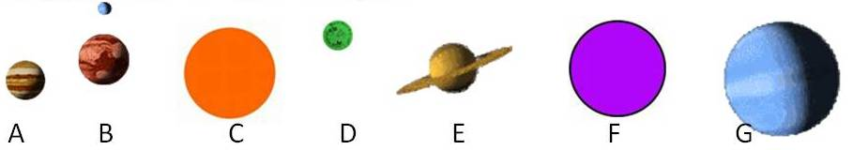

Write a complete description for this new imaginarian Solar System. Notice that C has coloured bands, F is plenty of craters and G has rings as Saturn.

Thank you

